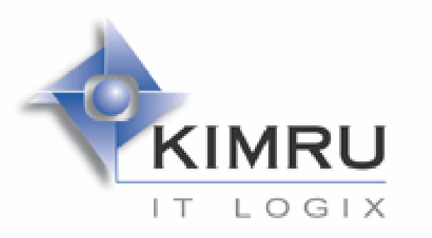

Introduction

Kimru is a value-driven company focused on the provision of integrated information technology infrastructure and profit-enhancing business solutions that are supported by cost- effective technical and maintenance services.
The company is committed to maintaining long-term relationships with its clients in order to help create and sustain competitive advantage in today's information-centric global economy.

Company Overview:

Kimru Marketing (Pty) Ltd trading as Kimru IT Logix was founded in 1997 by John Rundle with
12 years IT experience ranging from, consulting, distribution, retail sales, and corporate IT
sales.

Over the past 6 years, Kimru has gone through various changes in so far as it's offerings to the market place, from the outset the company offered only business consulting and related services.

In October 2001 Kimru signed an agreement for Orgplus distribution, support and training (on behalf of the US vendor Human Concepts) for the Southern Africa region. The latest addition to the software offering is Solid Converter, a utility from VoyagerSoft ( US vendor).

Kimru currently services & supports 65 Enterprise / Mid-market companies in South Africa , the

Top 15 customers are:

• South African Breweries
• Vodacom
• MTN
• Cell C
• Petro S.A
• DeBeers Group
• Rand Water Board
• Volkswagen S.A
• Department Agriculture
• Department Provincial & Local Government (4 Provinces)
• The Presidents Office
• British American Tobacco
• Unilever Group.
• Truworths Group
• Sappi Group

Andries Fourie who is a certified MCP, MCSE 2000, SCO CUSA, SCO ACE, Lucent Engineer, A+ Technician, SalesLogix Fundamentals Engineer and ACT! Consultant manages the company's sales, operations and support. Andries is also the Product manager for Orgplus and SolidConverter, and recently finished MCSD.net

What gives Kimru the edge?

The staff is highly skilled, motivated and self starting individuals with the desire to achieve. Management with its experience in the IT sector is able to implement tried and tested business solutions which facilitates low cost of ownership to its qualified customer base.

For more information on Kimru please visit

www.kimru.co.za

