Version 10

TurboCAD® Professional Version 10 achieves new levels of power and perfor- mance. Using the new LightWorks® 7.3 Photorealistic
rendering engine from LightWork Design, rendering performance is up to 40% faster than previous releases. The new version also includes an updated version of Spatial’s 3D ACIS® R11 solid modeling engine. The newer ACIS engine improves the solid modeling performance by up to 25%.

These performance enhancements, combined with:
• Spatial’s 3D Deformable Modeling using NURBS-based objects and powerful parametric architectural features
• Class leading design and presentation tools
• Use of 2D tools while in rendered mode, make
TurboCAD today’s best CAD value.

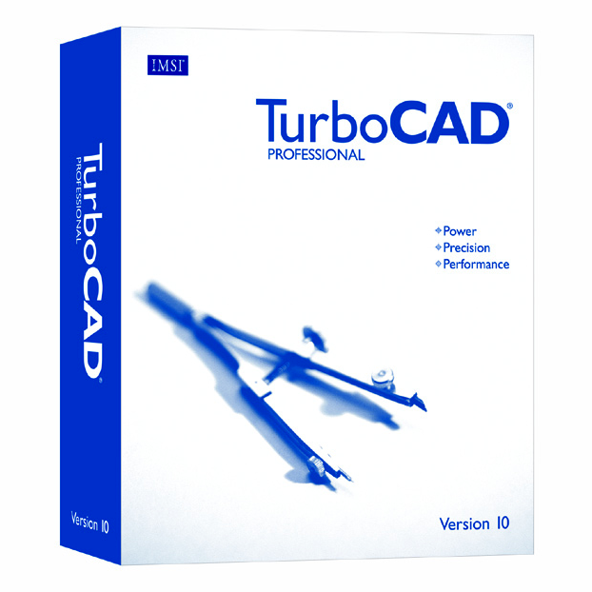

Advanced Mechanical Design
• NEW! Deformable modeling using NURBS
• NEW! Creation of solids from surfaces and surfaces from solids
• NEW! Powerful drafting palette
• NEW! Axis scaling of all ACIS objects
• NEW! STEP Import/Export ﬁlter
• NEW! Industry standard IGES ﬁlter
• IMPROVED! Facet editing of ACIS
3D objects and surfaces

Intelligent Architectural Design
• NEW! Support for interior & exterior materials on walls
• NEW! Wall direction indicators to enhance materials selection & block insertion
• NEW! Convert lines, polylines, circles and curves into walls
• IMPROVED! Roof editing, dimensioning and transform tools

Superior Artistic Design & Presentation
• NEW! Extensive options for hidden line rendering
• IMPROVED! Color selection and creation tools
• IMPROVED! Work in 2D or 3D
without leaving rendered mode
• IMPROVED! LightWorks® 7.3 Rendering Engine

Version 10

TurboCAD® Professional Version 10 is a versatile 2D/3D design application that breaks all barriers: price, power and performance.

Compatibility and Programmability TurboCAD Professional Version10 is ﬂuent in 28 of the most popular industry standard ﬁle formats including AutoCAD® DWG/DXF, Microstation® DGN, DesignCAD DCD, 3DS, IGES,
STEP and STL. You also have the option to publish your designs to HTML, JPG, and MTX. Also includes a complete Software Development Kit and a new Visual Basic® Macro Recorder.

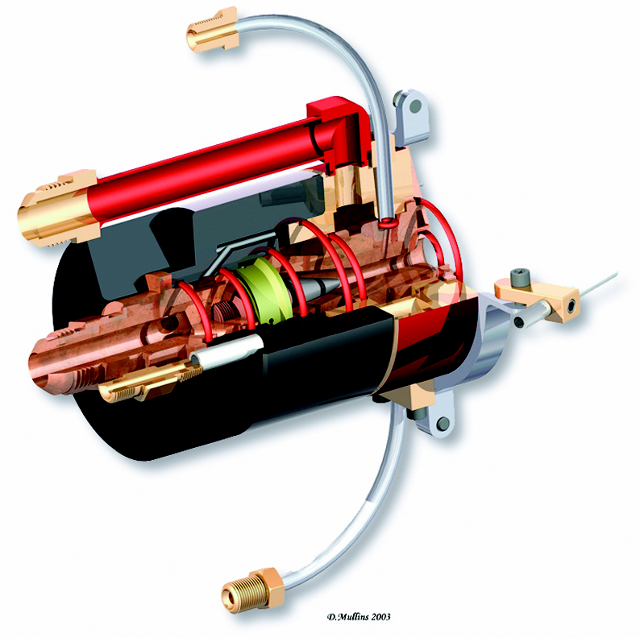

Target Market
The primary market includes experienced CAD users wanting more power, industry speciﬁc advanced features, and ﬁle compatibility with other CAD products
at an affordable price.

This includes professional CAD users looking to do architectural designs, mechanical designs, technical illustrations, artistic designs, and presentations.

Pricing
Suggested Retail Price: $795.95 USD

Speciﬁcations
Unit Size: 9 1/2” x 7 7/8” W 2 1/4” D Unit Weight: 2 lb. 1 oz.
Case Count: 20
Case Size: 23 1/4” L x 16 1/4’ W x 9 3/4” H

System Requirements
• Pentium II Processor or faster
• 256 MB RAM
• Super VGA graphics card
• Super VGA monitor capable of at least 800 x 600 resolution
• CD-ROM drive
• Windows® 98/Me/NT4/2000/XP UPC Code & Part Number UPC Code: 7 30526 35507 9
ISBN: 1-57632-350-1
Part Number(s): English: 00TCP510CC



© 2004 TCP10SS2004 1-800-833-8082

